Project phase-5

NOISE POLLUTION MONITORING

SUBMITTED BY:

S.SHARATHKUMAR

EMAIL:sharathkumar8791@gmail.com

ROL NO: au723921104043

Project Objectives:

The project's objectives typically revolve around collecting and analyzing real-time data from physical objects, machines, or environments to gain insights, automate processes, or improve decision-making. Specific goals can vary, but common objectives include:

1.Monitor and control physical assets remotely.

2.Gather and analyze data for predictive maintenance.

3.Improve operational efficiency and reduce costs.

4.Enhance user experiences through mobile applications.

5.Ensure data security, privacy, and compliance with regulations.

IoT Sensor Deployment:

IoT sensor deployment involves placing sensors and actuators in the physical environment to collect data or control devices. Key steps include:

1.Sensor Selection: Choose appropriate sensors for the specific application (e.g., temperature, humidity, motion, GPS, etc.).

2.Hardware Setup: Install and connect sensors to a microcontroller or gateway device.

3.Network Connectivity: Establish a communication channel (e.g., Wi-Fi, cellular, LoRa, or MQTT) to transmit data to the cloud.

4.Data Aggregation: Collect and preprocess sensor data for transmission.

5.Power Management: Ensure sensors have a reliable power source, which may involve battery, solar, or energy harvesting methods.

Platform Development:

The IoT platform is the central hub for managing and processing data from the sensors. It typically includes the following components:

1.Data Ingestion: Receive and store data from sensors in a database or data storage.

2.Data Processing: Perform real-time analytics, data cleansing, and transformation.

3.Device Management: Monitor sensor health, firmware updates, and security.

4.User Authentication: Secure access control for both users and devices.

5.Integration: Connect to external services, APIs, or third-party platforms.

6.Visualization: Display data through dashboards and reports.

7.Alerts and Notifications: Send notifications or trigger actions based on predefined rules.

Mobile App Development:

Developing a mobile app to interact with the IoT system is crucial for user engagement. Key components include:

1.User Interface (UI) Design: Create an intuitive and user-friendly interface for data visualization and control.

2.Data Integration: Access data from the IoT platform through APIs.

3.Real-time Updates: Enable live data streaming and push notifications.

4.User Authentication: Implement secure login and authentication mechanisms.

5.Device Control: Allow users to control IoT devices or systems remotely.

6.Customization: Offer user-specific settings and preferences.

7.Offline Functionality: Ensure the app can work with intermittent or no internet connectivity.

8.Code Implementation:

The code implementation phase involves writing the software for the IoT sensors, the IoT platform, and the mobile app. This typically includes:

Sensor Firmware: Write code for microcontrollers to collect data, establish connections, and transmit data.

Backend Development: Create the server-side code for the IoT platform, including data processing, storage, and APIs.

Mobile App Development: Write code for iOS and Android apps using native or cross-platform frameworks (e.g., React Native, Flutter).

Data Handling: Implement data validation, encryption, and secure communication protocols (e.g., HTTPS, MQTT, CoAP).

User Authentication: Develop user authentication and authorization mechanisms.

Testing: Conduct unit testing, integration testing, and security testing.

Deployment: Deploy the system components to the cloud or on-premises servers.

Maintenance: Continuously update and maintain the system to ensure security and performance.

Each of these steps requires a multidisciplinary team with expertise in hardware, software, data analysis, and user experience design to successfully achieve the project's objectives.

IoT Sensors:

To create diagrams or schematics for your IoT sensors, you can use various tools such as Microsoft Visio, draw.io, or any other diagramming software. You would typically illustrate the components and connections of your IoT sensor, including sensors, microcontrollers, power sources, and communication modules. If you need to represent a specific sensor module, you might find its datasheet and use its technical drawings.

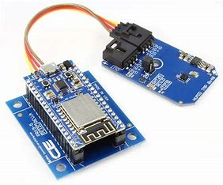

Noise Pollution Information Platform:

Visual representation of your noise pollution information platform can be created using wireframing or prototyping tools like Sketch, Figma, or Adobe XD. These tools allow you to design the user interface (UI) and user experience (UX) of your platform. You can create screen mockups and flowcharts to illustrate how users will interact with the system.

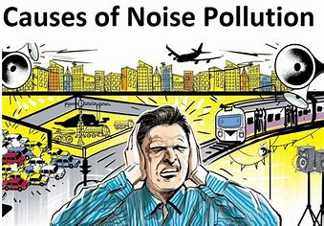

Mobile App Interfaces:

To design mobile app interfaces, you can use the same wireframing or prototyping tools mentioned above. Create wireframes and mockups for different screens of your mobile app, including the home screen, settings, and any other relevant screens. You can also use design tools like Adobe Illustrator or Photoshop for more detailed UI design.

For including screenshots of actual interfaces, you would need to have a working implementation of the IoT system and the mobile app. Once these are developed, you can capture screenshots directly from your devices.

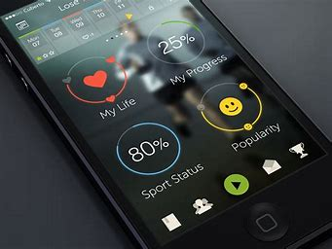

Remember that creating diagrams, schematics, and screenshots is a visual design and technical implementation task that requires specific tools and skills. If you're not familiar with these tools or don't have design experience, you might consider hiring a graphic designer or a UI/UX designer to help you create these visual assets. Additionally, sharing specific details about your IoT project can help provide more targeted guidance or examples.

A real-time noise level monitoring system plays a significant role in promoting public awareness and contributes to noise pollution mitigation in several ways. Here's an explanation of how it accomplishes this:

1.Real-time Data Availability: These monitoring systems continuously collect and analyze noise data from various locations, making the information readily available to the public. This real-time data can be accessible through websites, mobile apps, or public displays, allowing individuals to check noise levels in their area at any time.

2.Public Awareness: The availability of real-time noise data raises public awareness about noise pollution in their surroundings. When people can see and understand the noise levels they are exposed to, they become more conscious of the issue and its potential impact on their health and well-being.

3.Identification of Noisy Areas: Noise level monitoring systems help identify specific areas with consistently high noise levels. This information can be used to pinpoint noisy hotspots, such as busy intersections, construction sites, or industrial zones. This enables communities and authorities to focus their efforts on mitigating noise in these areas.

4.Community Engagement: Real-time noise data empowers communities to engage in discussions and advocacy for noise reduction. They can use the data to raise concerns with local authorities, property developers, and industries responsible for noise pollution.

5.Public Health Awareness: The data provided by noise monitoring systems can be used to educate the public about the potential health risks associated with prolonged exposure to high noise levels. Increased awareness can lead to behavioral changes, such as using ear protection or advocating for noise reduction measures.

6.Compliance Monitoring: Noise monitoring systems also assist in enforcing noise regulations and ordinances. Authorities can use the data to ensure that businesses, construction sites, and events are complying with noise limits and take appropriate action if necessary.

7.Noise Reduction Initiatives: Real-time data can serve as a foundation for implementing noise reduction initiatives and policies. This may include scheduling noisy activities during off-peak hours, designing noise barriers, and enforcing stricter noise standards for specific areas.

8.Early Warning Systems: Some monitoring systems can provide alerts to the public when noise levels exceed safe or tolerable limits. This feature can be especially beneficial in emergency situations, such as sudden loud noises from industrial accidents or transportation incidents.

9.Research and Policy Development: Data collected from real-time monitoring systems can be valuable for researchers and policymakers. It helps in assessing the effectiveness of noise mitigation measures, conducting studies on the impact of noise pollution on public health, and developing evidence-based policies for noise reduction.

10.Behavioral Change: As individuals become more aware of their noise environment, they may naturally adapt their behavior to reduce noise pollution. This could lead to more considerate use of personal electronic devices, quieter transportation options, and reduced unnecessary noise.

In summary, a real-time noise level monitoring system promotes public awareness by providing accessible and up-to-date information on noise levels in the community. It empowers individuals, communities, and authorities to take action, fosters compliance with noise regulations, and contributes to the development of noise mitigation strategies, ultimately helping to reduce the adverse effects of noise pollution on public health and well-being.